***Lecture Two − Techniques of Integration***

***Section* 2.1 – Integration by Parts**

Integration by parts is a technique for simplifying integrals of the form



***Example***: 

**Integration by Parts Formula**



Let *u* and *v* be differentiable functions of *x*. 

**Guidelines for integration by Parts**

1. Let *dv* be the most complicated portion of the integrand that fits a basic integration formula. Let *u* be the remaining factor.
2. Let *u* be the portion of the integrand whose derivative is a function simpler than *u*. Let *dv* be the remaining factor.

***Example***

Evaluate: 

***Solution***

***Let***: 

 



***Example***

Evaluate: 

***Solution***

Let:



 





**Tabular Integration**

***Example***

Evaluate 

***Solution***

|  |  |  |  |  |  |  |  |  |  |  |  |  |  |
| --- | --- | --- | --- | --- | --- | --- | --- | --- | --- | --- | --- | --- | --- |
| |  |  |  | | --- | --- | --- | | **&**  **derivatives** |  |  | |  |  |  | |  |  |  | |  |  |  |   It is called ***tabular integration*** | Let: |

***Example***

|  |  |  |
| --- | --- | --- |
|  | |  |
| **+** |  |  |
| **−** |  |  |
| **+** |  |  |
| **−** |  |  |

Evaluate 

***Solution***



***Example***

Evaluate 

***Solution***

|  |  |  |  |  |  |  |  |  |  |  |  |  |  |
| --- | --- | --- | --- | --- | --- | --- | --- | --- | --- | --- | --- | --- | --- |
|  | |  |  |  | | --- | --- | --- | |  |  |  | | **+** |  |  | | **-** |  |  | | **+** |  |  | |

Let: 

 Let: 













***Example***

Obtain a formula that expresses the integral 

***Solution***

Let: 





















***Example:*** 



**Evaluating Definite Integrals by Parts**

***Example***

Find the area of the region bounded by the curve  and the *x*-axis from *x* = 0 to *x* = 4.

***Solution***

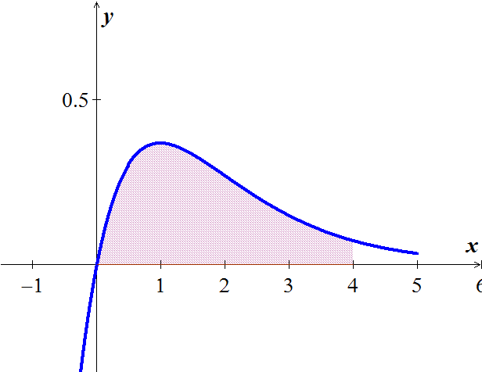

|  |  |  |
| --- | --- | --- |
|  |  |  |
| + |  |  |
| − |  |  |







**2nd *Method***

Let:  















***Formula***

Evaluate 

|  |  |  |
| --- | --- | --- |
|  |  |  |
| **+** |  |  |
| **−** |  |  |
| **+** |  |  |
| **−** |  |  |
|  |  |  |





***Exercises*** ***Section* 2.1 – Integration by Parts**

(**1 − 92**) Evaluate the integrals

|  |  |  |
| --- | --- | --- |
|  |  |  |
|  |  |  |

(**94 − 98**) Use integration by parts to establish the reduction formula

1. 
2. 
3. 
4. 
5. 
6. Find the indefinite integral: 
7. Find the volume of the solid generated by the region bounded by , and the  on  is revolved about the .
8. Find the volume of the solid generated by revolving the region in the first quadrant bounded by the coordinate aces, the cure , and the line  about the line 
9. Find the volume of the solid generated by revolving the region in the first quadrant bounded by the coordinate axes, the cure , and the line , about
10. the line 
11. the line 
12. Find the volume of the solid that is generated by the region bounded by , and the coordinate axes is revolved about the .
13. Find the volume of the solid that is generated by the region bounded by , and the  on  is revolved about the line .
14. Find the volume of the solid that is generated by the region bounded by , and the  on  is revolved about the .
15. Find the area of the region generated when the region bounded by  and  on the interval .
16. Find the area between the curves 
17. Determine the area of the shaded region bounded by



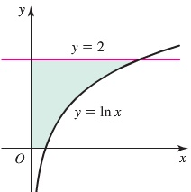

1. The curves  are shown in the figure for .

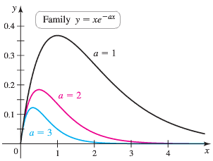

1. Find the area of the region bounded by  and the *x-*axis on the interval [0, 4].
2. Find the area of the region bounded by  and the *x-*axis on the interval [0, 4] where 
3. Find the area of the region bounded by  and the *x-*axis on the interval [0, *b*]. Because this area depends on *a* and *b*, we call it where  and .
4. Use part (*c*) to show that 
5. Does this pattern continue? Is it true that 
6. Suppose a mass on a spring that is slowed by friction has the position function 
7. Graph the position function. At what times does the oscillator pass through the position ?
8. Find the average value of the position on the interval .
9. Generalize part (*b*) and find the average value of the position on the interval , for 
10. Given the region bounded by the graphs of , find
11. The area of the region.
12. The volume of the solid generated by revolving the region about the 
13. The volume of the solid generated by revolving the region about the 
14. The centroid of the region
15. The region *R* is bounded by the curve  and the  on the interval . Find the volume of the solid that is generated when *R* is revolved in the following ways

|  |  |
| --- | --- |
| 1. About the 2. About the | 1. About the line 2. About the line |

1. A string stretched between the two points  and  is plucked by displacing the string h units at its midpoint. The motion of the string is modeled by a ***Fourier Sine series*** whose coefficients are given by



Find 